QUESTION 1
SELECT
s. first_name,
s. last_name,
s. occupation,
p. department_name
FROM employee_salary s
JOIN parks_departments p
ON s.dept_id = p.department_id;

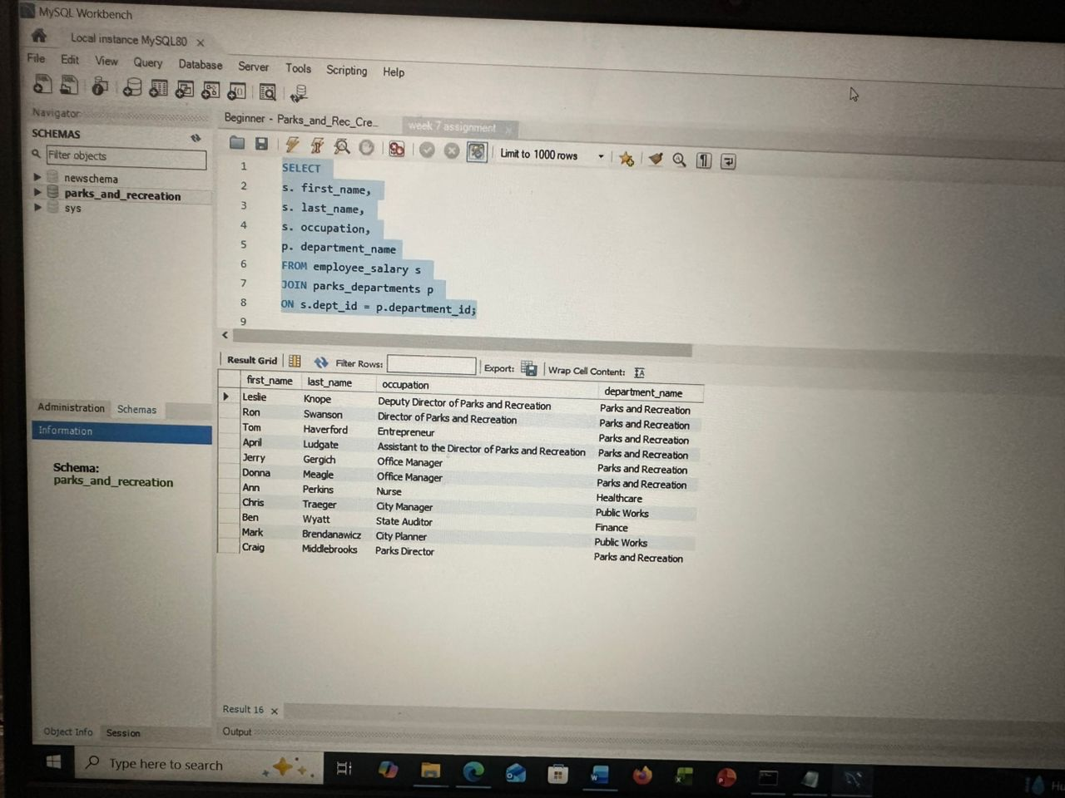

QUESTION 2
SELECT occupation,
AVG(salary) AS average_salary,
MIN(salary) AS minimum_salary,
MAX(salary) AS maximum_salary
FROM employee_salary
GROUP BY occupation;

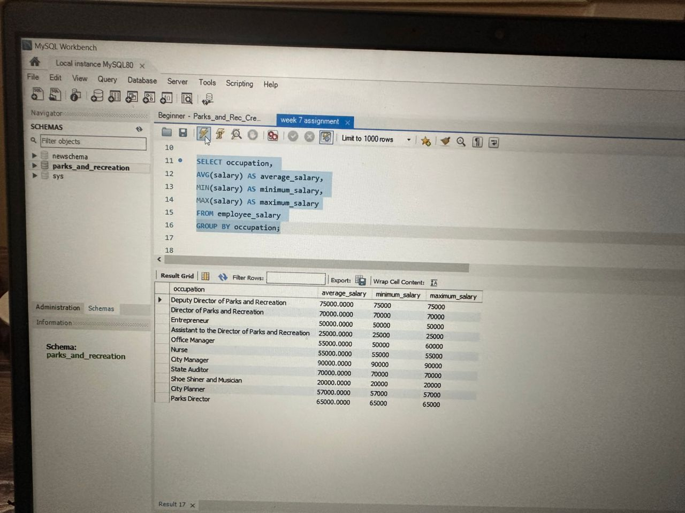
QUESTION 3
SELECT first_name, last_name, salary
FROM employee_salary
WHERE salary > 50000;

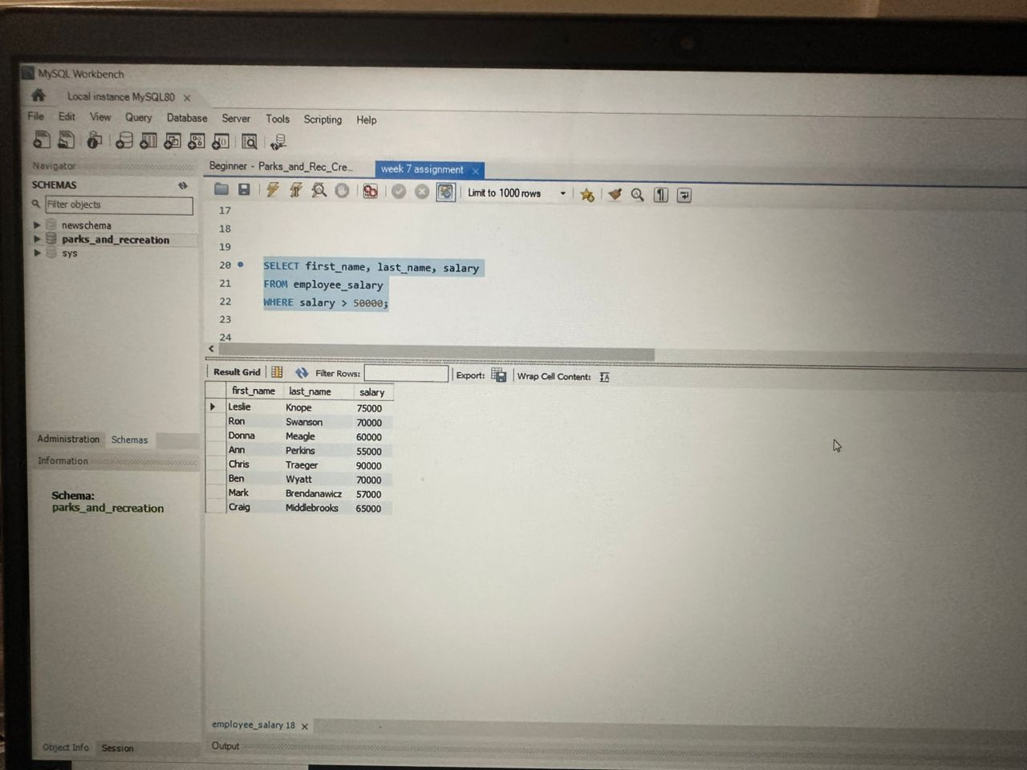

QUESTION 4
SELECT
ed.first_name,
ed.last_name,
COALESCE(es.occupation, 'Not Assigned') AS occupation
FROM employee_demographics ed
LEFT JOIN employee_salary es
ON ed.employee_id = es.employee_id;

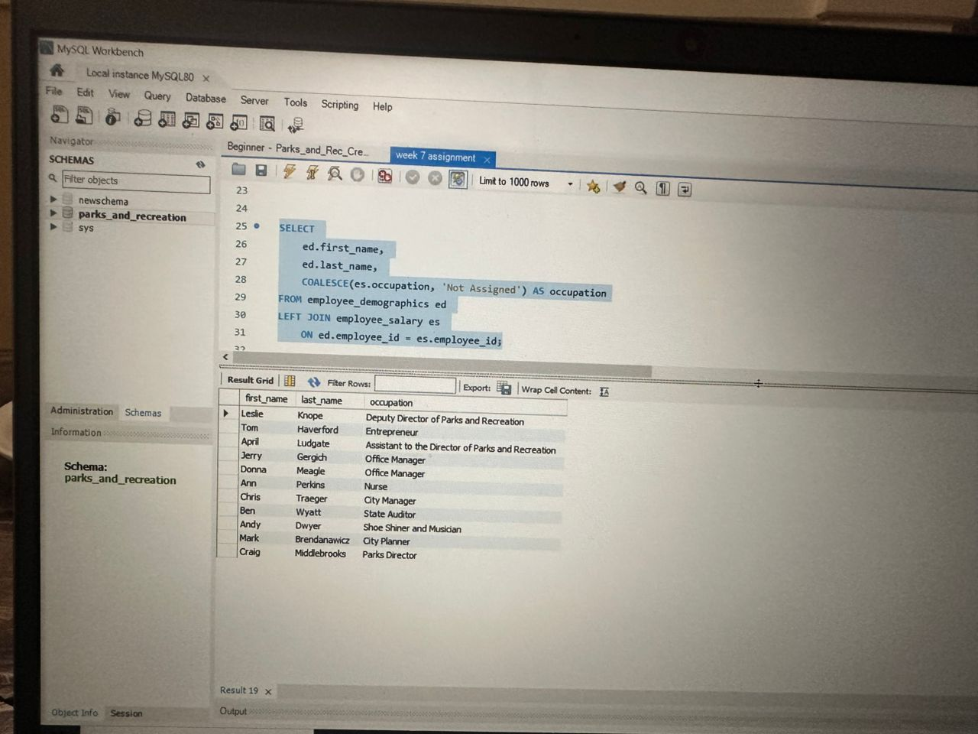
QUESTION 5
SELECT
ed.first_name,
ed.last_name,
pd.department_name,
CASE
WHEN pd.department_name = 'Parks and Recreation' THEN 'Eligible for 10% Bonus'
WHEN pd.department_name = 'Finance' THEN 'Eligible for 15% Bonus'
ELSE 'No Bonus'
END AS bonus_category
FROM employee_demographics ed
LEFT JOIN employee_salary es
ON ed.employee_id = es.employee_id
LEFT JOIN parks_departments pd
ON es.dept_id = pd.department_id;

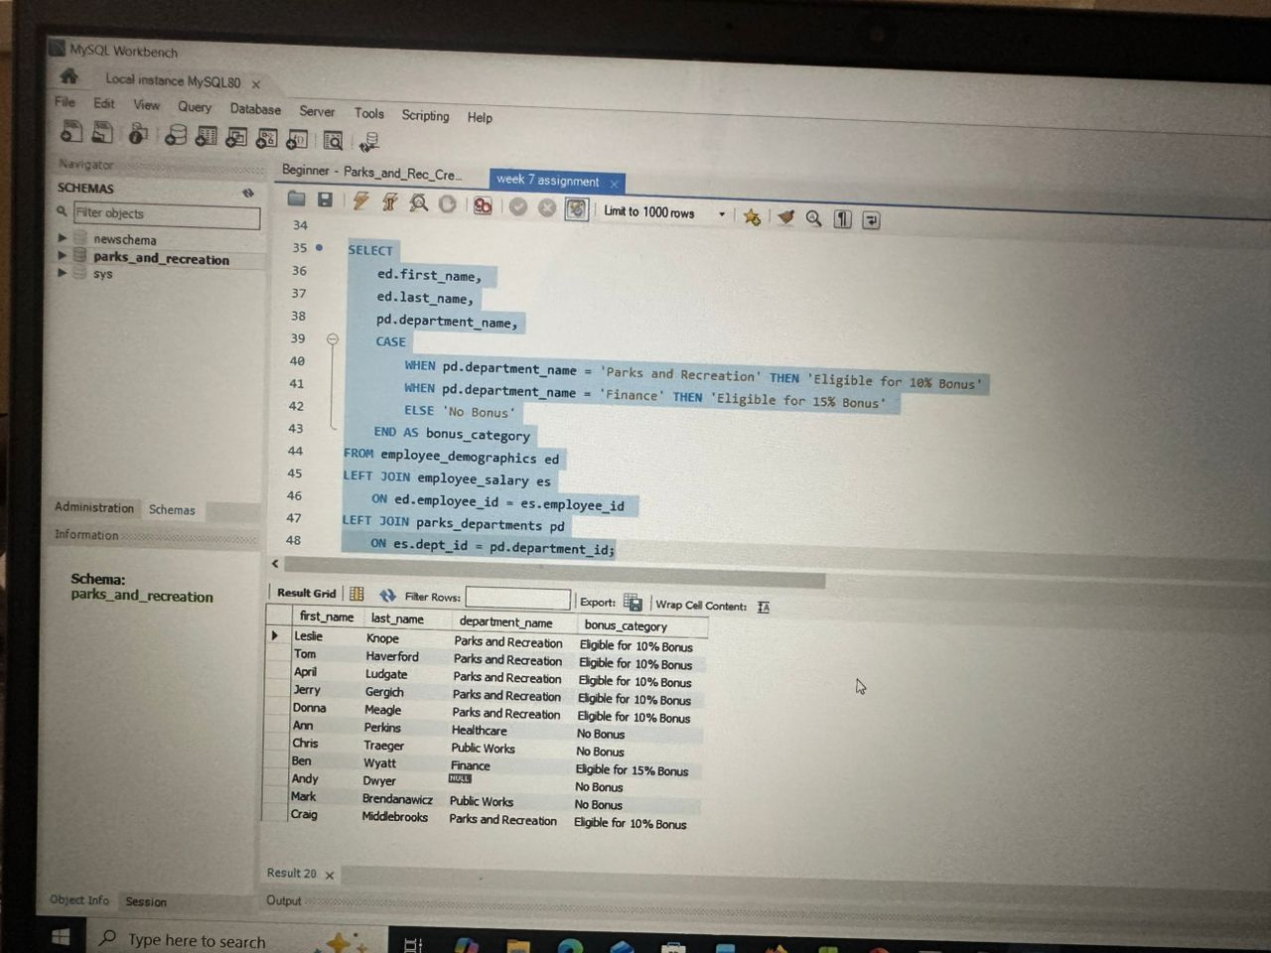

CORRECTION OF THE ASSIGNMENT
QUESTION 1
SELECT
s. first_name,
s. last_name,
s. occupation,
p. department_name
FROM employee_salary s
JOIN parks_departments p
ON s.dept_id = p.department_id;

QUESTION 2
SELECT d. department_name,
AVG(s. salary) as "Mid Salary",
MIN(s. salary) as "Lowest Salary",
MAX(s. salary) as "Highest Salary"
FROM employee_salary s
JOIN parks_departments d
ON d.department_id = s.dept_id
GROUP BY d.department_name;
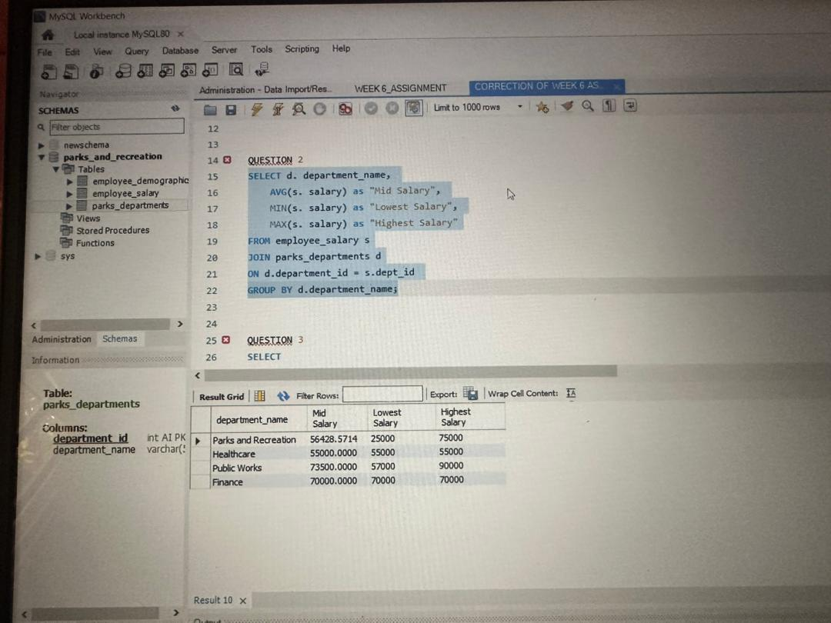
QUESTION 3
SELECT
e.first_name,
e.last_name,
e.salary
FROM employee_salary e
WHERE e.salary > (SELECT AVG(salary) FROM employee_salary);

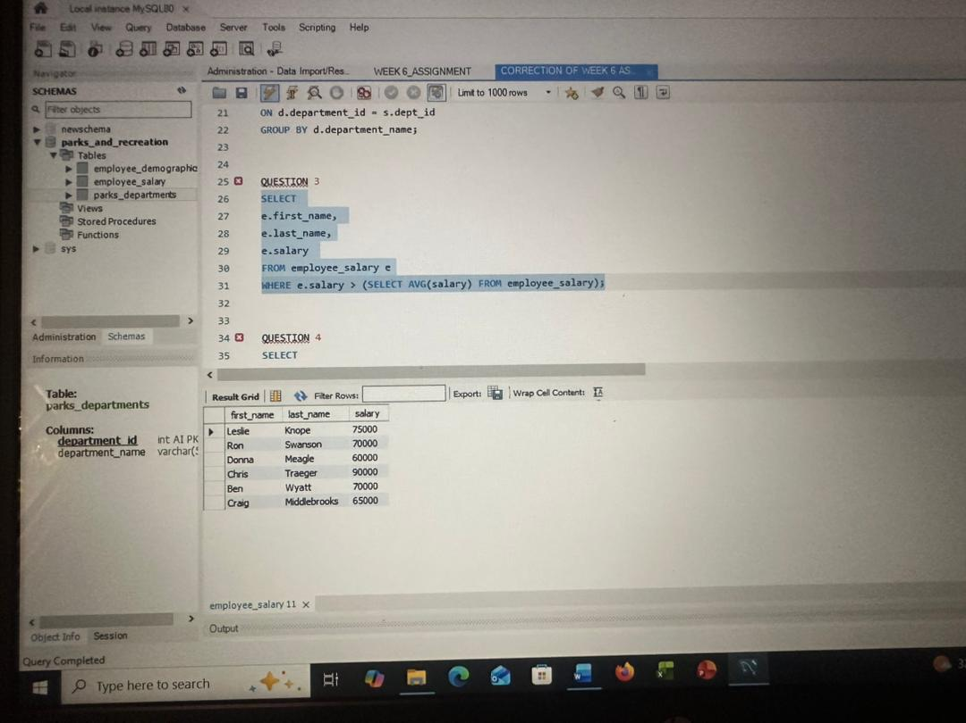

QUESTION 4
SELECT
ed.first_name,
ed.last_name,
ed.age,
ed.gender,
es.salary,
COALESCE (es.occupation, "Not Assigned") AS Occupation
FROM employee_demographics ed
JOIN employee_salary es
ON ed.employee_id = es.employee_id;

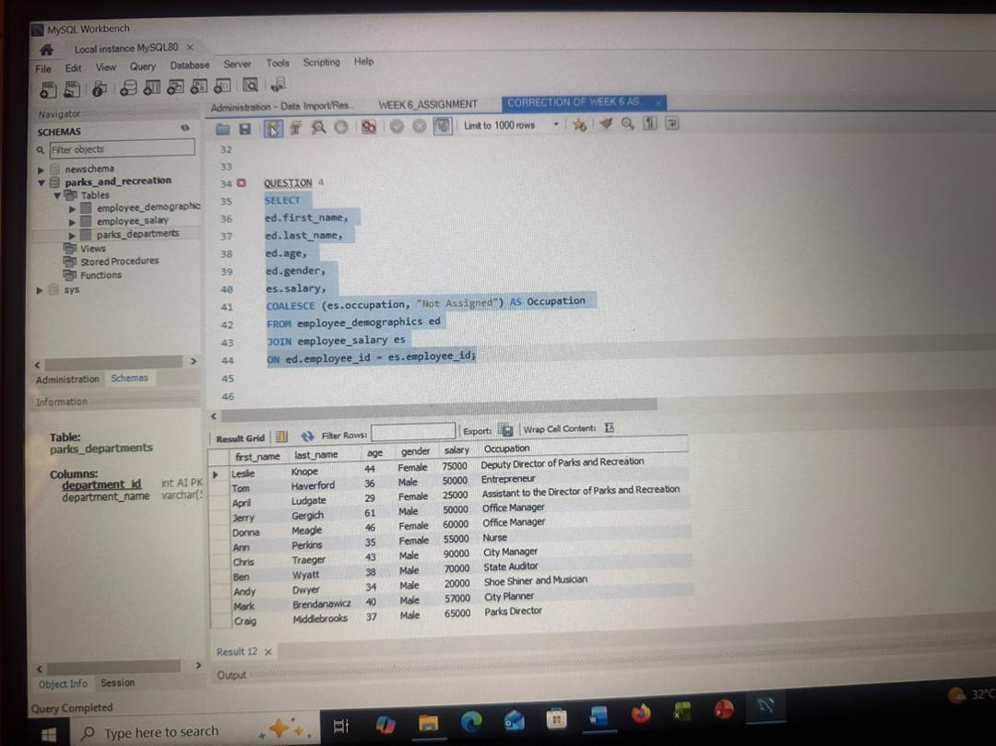

QUESTION 5
SELECT
es.first_name,
es.last_name,
d.department_name,
CASE
WHEN d.department_name = 'Parks and Recreation' THEN 'Eligible for 10% Bonus'
WHEN d.department_name = 'Finance' THEN 'Eligible for 15% Bonus'
ELSE 'No Bonus'
END AS bonus_category
FROM employee_salary es
JOIN parks_departments d
ON es.dept_id = d.department_id;
